

**DEPARTMENT OF**

**ISE**

**Project Report on**

**HYBRID WEB DEVELOPMENT**

# CFC SHOOTER GAME



**STUDENT NAME : SARANG R**

**USN : 1MS22CY063**

# Ramaiah Institute of Technology

**(Autonomous Institute, Affiliated to VTU) MSR Nagar, MSRIT Post, Bangalore-560054** October – November, 2023

**INDEX**

PROBLEM STATEMENT ............................................................................ Pg 2

INTRODUCTION ......................................................................................... Pg 3

IMPLEMENTATION .................................................................................... Pg 4

OUTPUT ......................................................................................... Pg 12

## Problem Statement

Create an immersive and educational space shooter game with the goal of increasing awareness about the harmful effects of chlorofluorocarbons (CFCs) on the ozone layer. Players will navigate a spacecraft armed with anti-CFC weapons in a dynamic interstellar setting. The main mission is to intercept and eliminate CFC particles before they penetrate the ozone layer, providing players with a simulated experience of the genuine environmental threat posed by these compounds to Earth's protective atmosphere.

## Introduction

Welcome to the CFC Shooter, an innovative and educational space shooter game designed to shed light on the detrimental impact of chlorofluorocarbons (CFCs) on the ozone layer. In this engaging gaming experience, players assume control of a spacecraft armed with anti-CFC weaponry, embarking on a mission to safeguard the Earth's atmospheric shield.

PURPOSE:

The primary purpose of the CFC Shooter is to raise awareness about the environmental consequences of CFCs, synthetic compounds known for their role in ozone layer depletion. Through interactive gameplay, users are not only entertained but also educated about the urgency of addressing this global environmental challenge.

WORKING OF THE PROJECT:

Players navigate through an immersive interstellar environment, facing the task of intercepting and destroying CFC particles before they breach the ozone layer. The game employs realistic physics and mechanics to simulate the actual threat posed by these compounds, providing players with an authentic experience of the consequences of CFC emissions.

USAGE:

The CFC Shooter is designed for players of all ages who seek an entertaining yet educational gaming experience. Whether you're a casual gamer or an environmental enthusiast, the game offers an accessible platform to learn about CFCs and their impact on the ozone layer while enjoying an engaging space shooter adventure.

By blending entertainment with education, the CFC Shooter not only aims to captivate players but also instill a sense of environmental responsibility. As you embark on this thrilling journey through space, you'll contribute to a greater understanding of the importance of preserving our planet's protective atmospheric layer. Get ready to shoot down CFCs and become a champion in the fight for a sustainable and healthier Earth!

## Implementation

### ozone.html

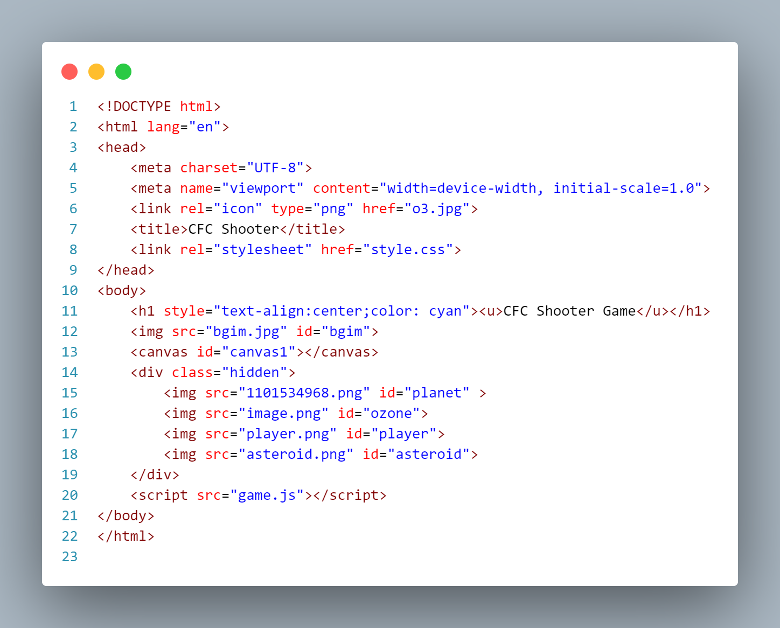

### style.css

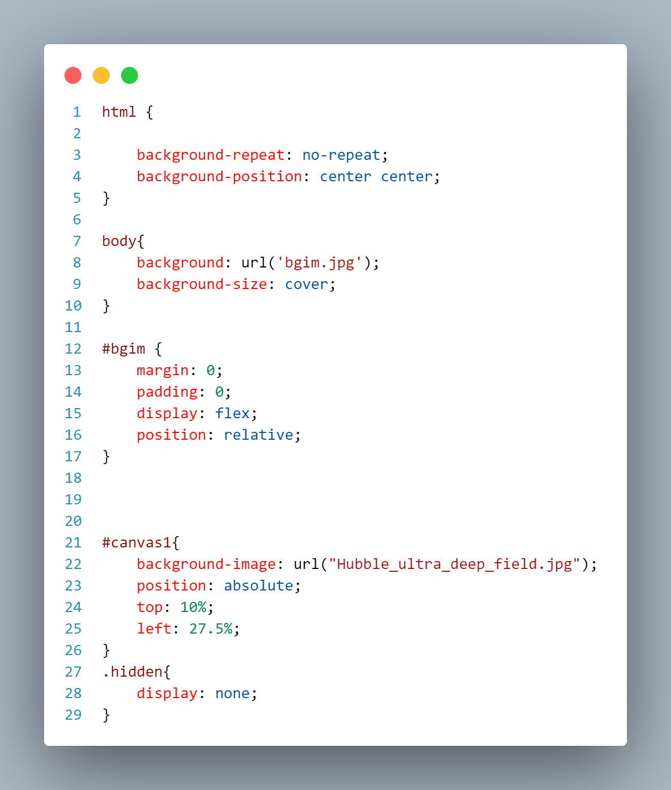

### game.js

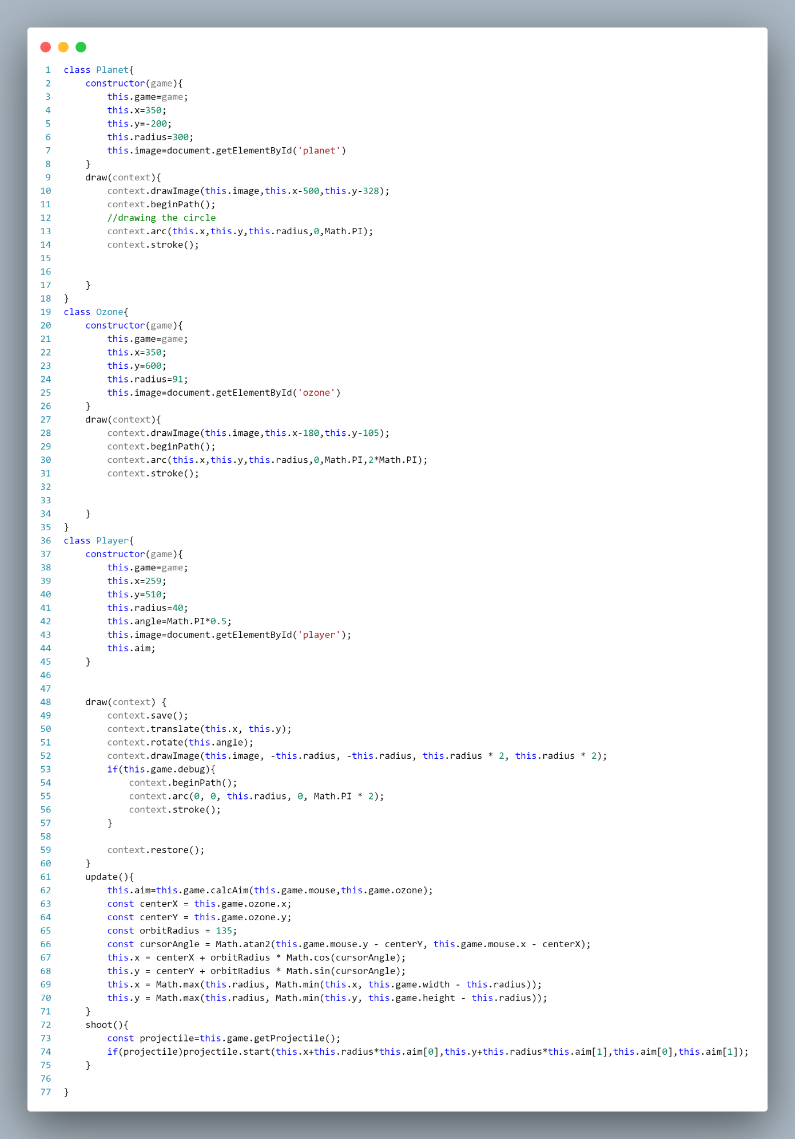

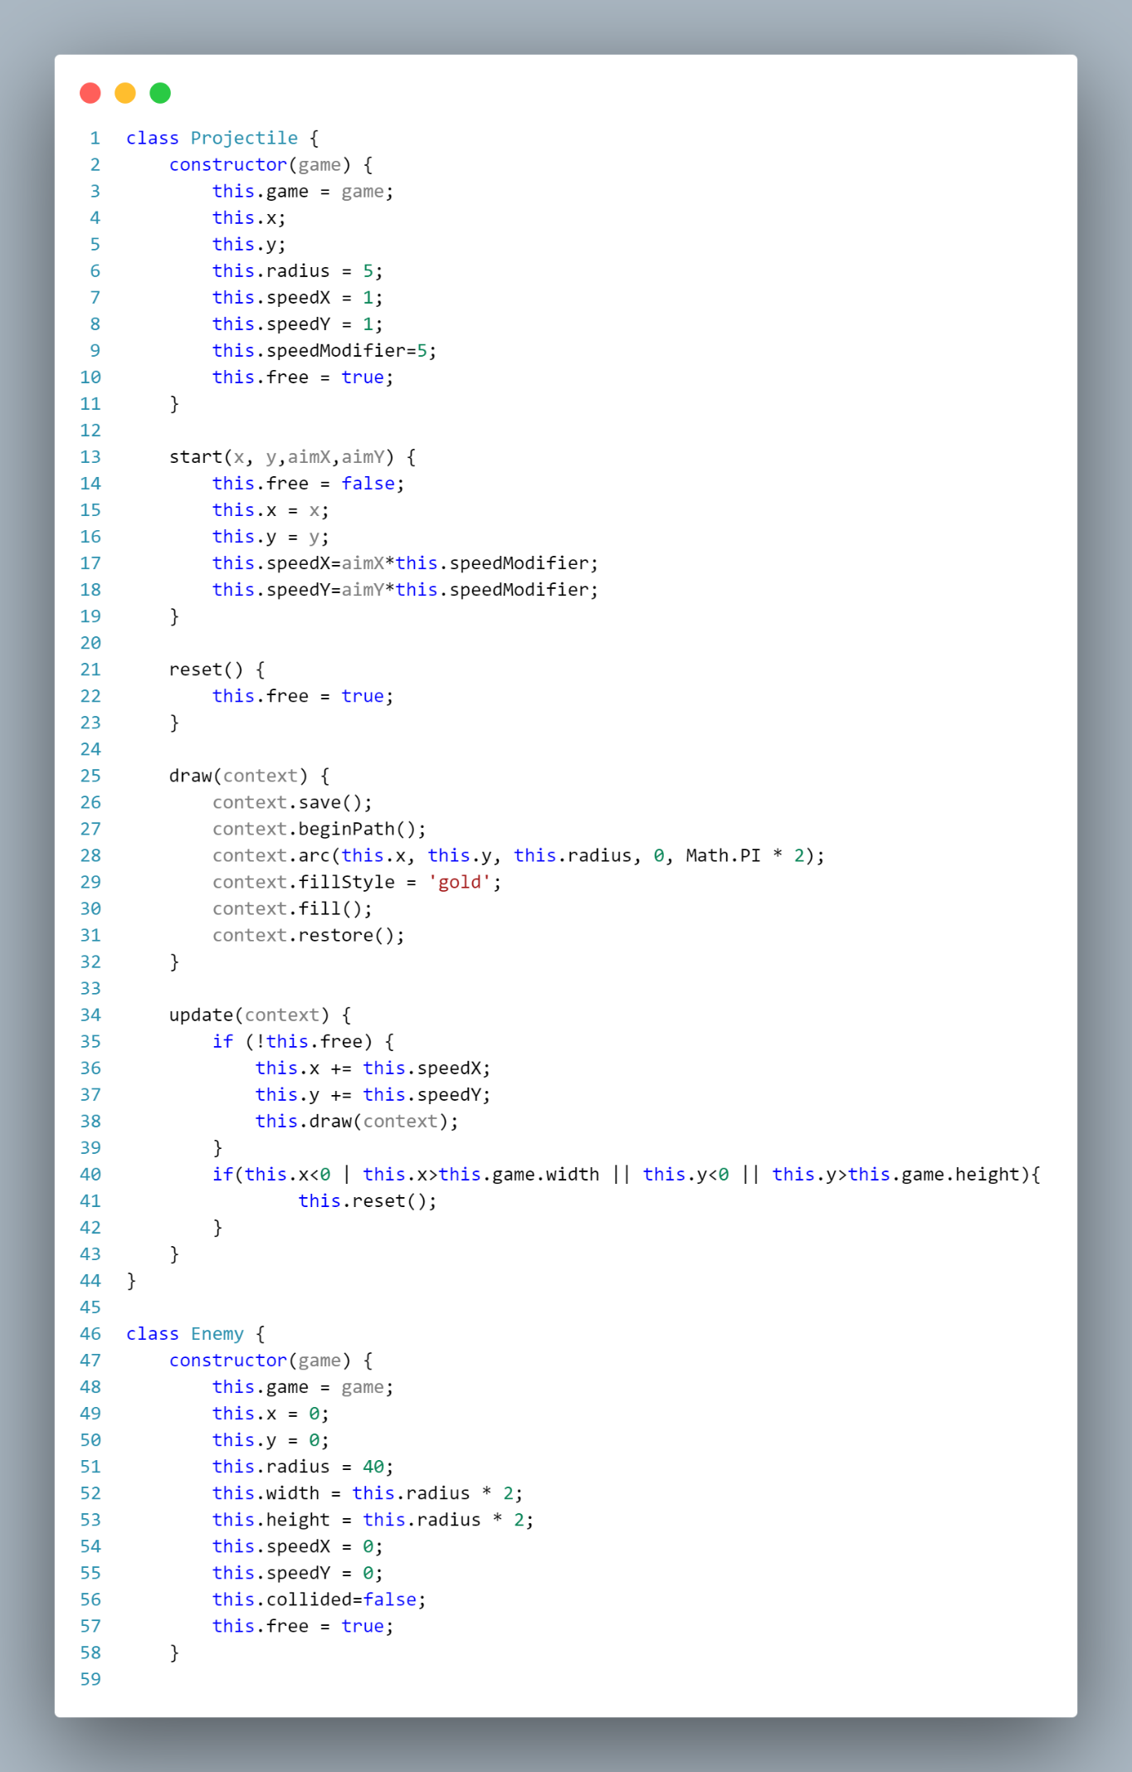

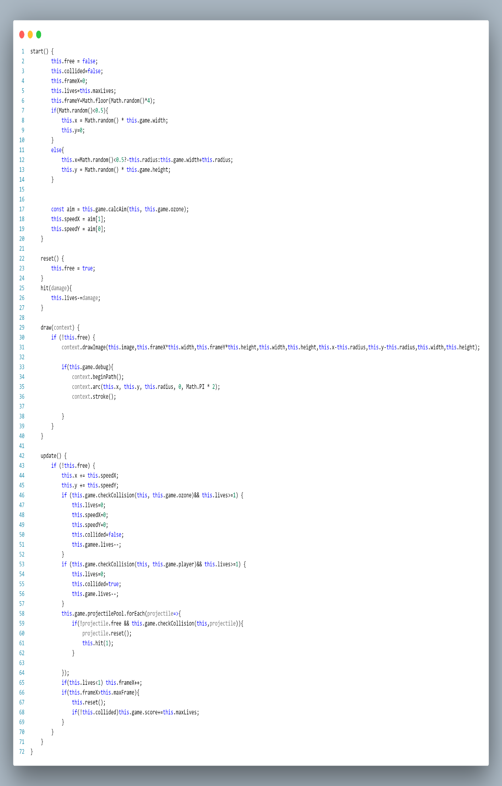

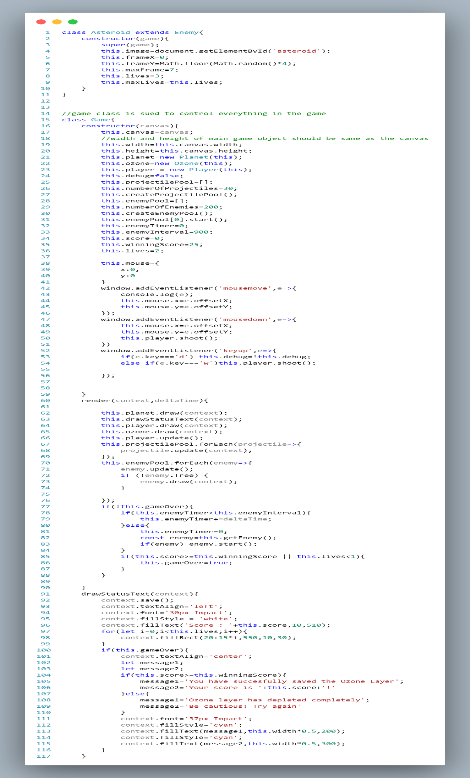

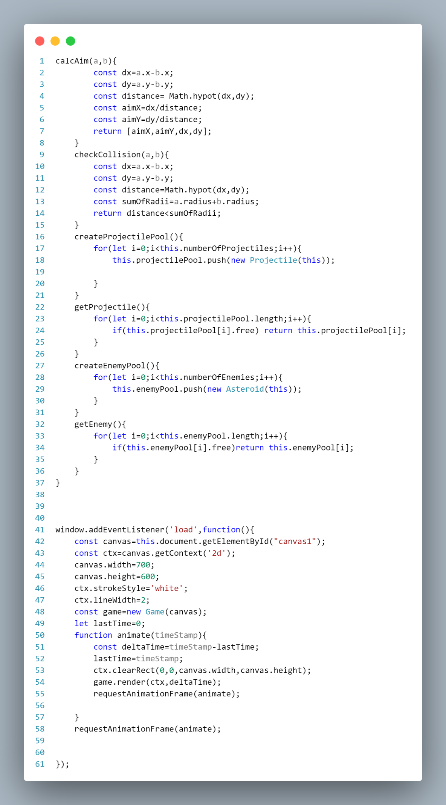

## Files

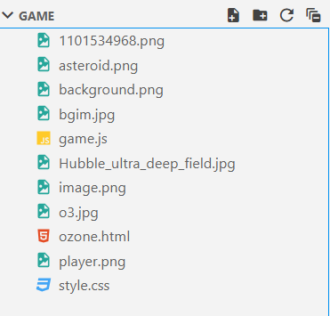

***Output***



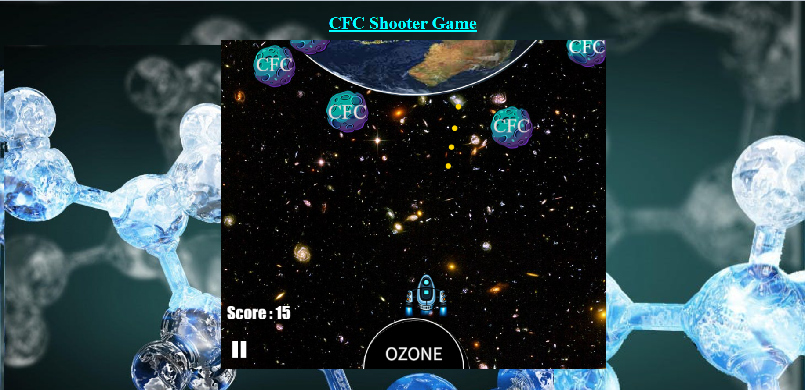

***Figure 1: CFC shooter in action***

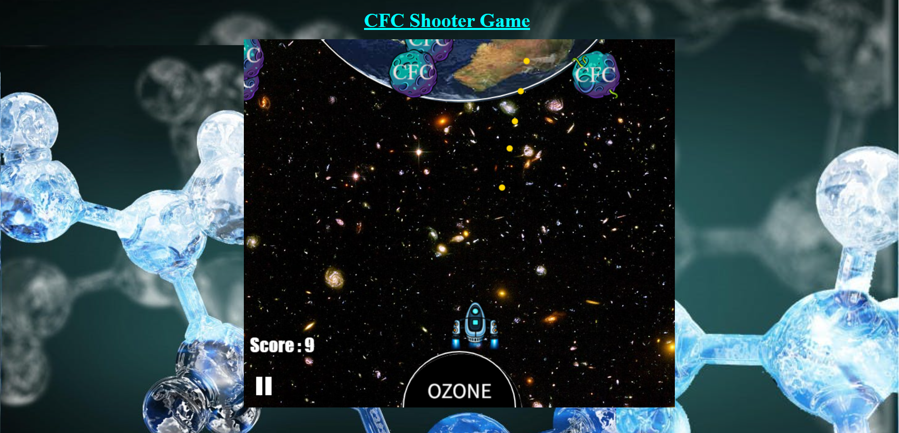

***Figure 2: bullets in action, destruction of a cfc carries 3 points and adds 3 points to the score. The two rectangular bars at the bottom depict the lives available.***

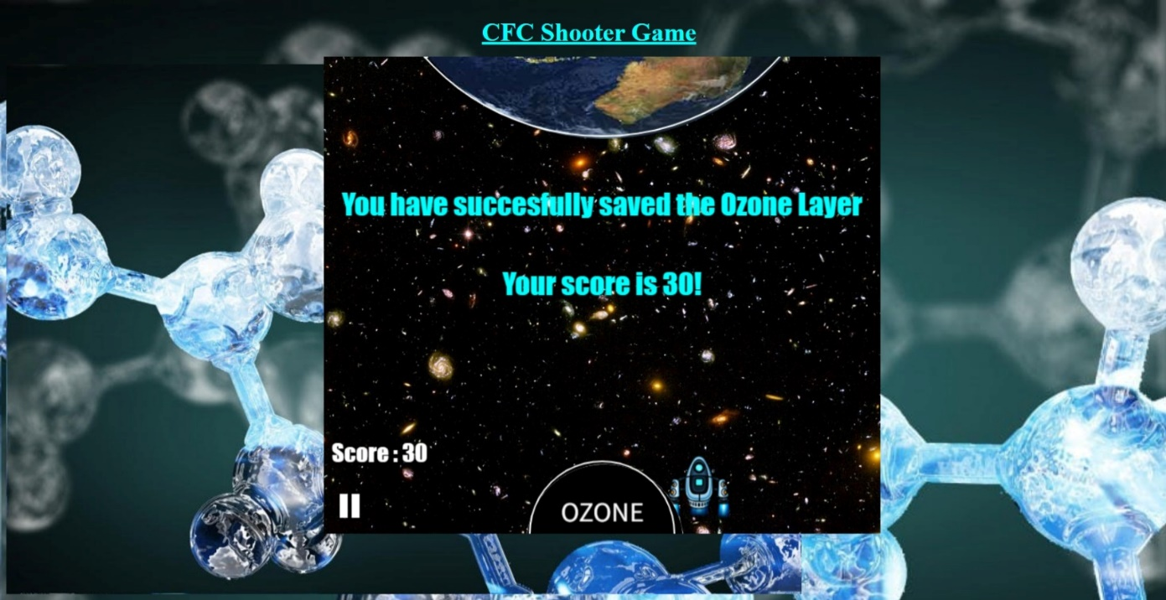

***Figure 3: When the score reaches more than 25 then the player has successfully won the game and saved the ozone layer***

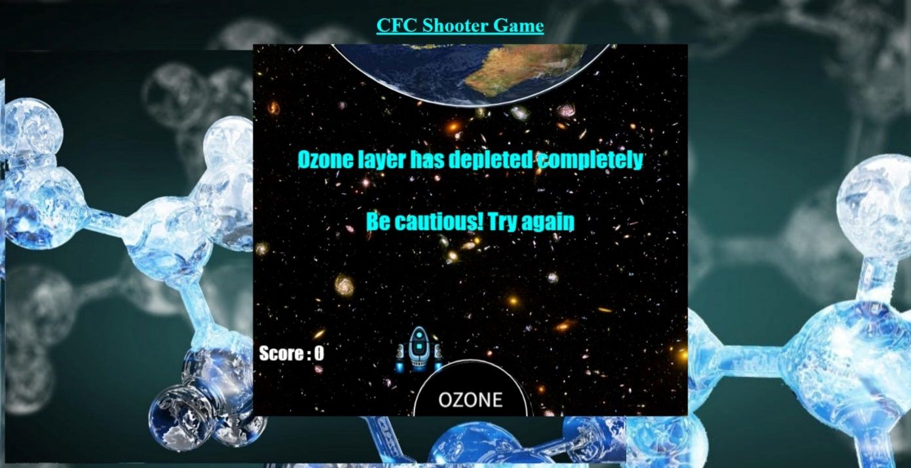

***Figure 4: When the cfc’s come in contact with the then the player loses his life. Player has 2 lives and if both the lives are exhausted then the player loses the game. The two rectangular bars at the bottom depict the lives available.***